Google.com Walk Through

In this document I have provided an example of how the first tutorial walkthrough for our website extension for Google.com would flow. I have each step of the walkthrough numbered as well as arrows pointing to the part of the website I am referencing in that step. I also have provided content that will be added in the dialog box for each step as well as what type of dialog box will be utilized in each step, (with or without arrows) **look out for the bold acronyms**. Each time you see an acronym after a line of text, that text should be in its own dialog box. The content for each step I have here is also formatted in the json file located here *summer21-sps-22\src\Content\googleTutorialContent.json* for implementation.

Key:

|  |  |
| --- | --- |
| **DBA** (A dialog box with arrows): the pop will have an arrow and will reference a specific part of the website | Click the Search bar!  [content] |
| **DBWA** (dialog box without arrows): The dialog box will not reference or have an arrow pointing to a portion of the website. | What is a Search bar?  [content] |

1. Explain gmail
   1. This is a link that will take you to your gmail account, if you are logged in. Click the word ‘Gmail’ to see! **DBA**

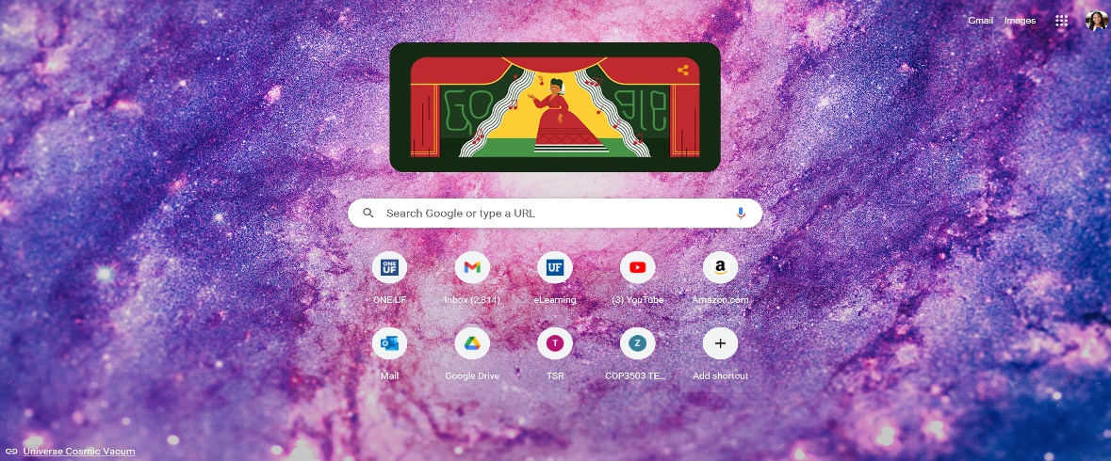

1. Explain images tab
   1. This is a link that if clicked on, will take you to Googles’ images search engine. There you can type anything in the search bar and Google will populate thousands of images of what you typed! **DBA**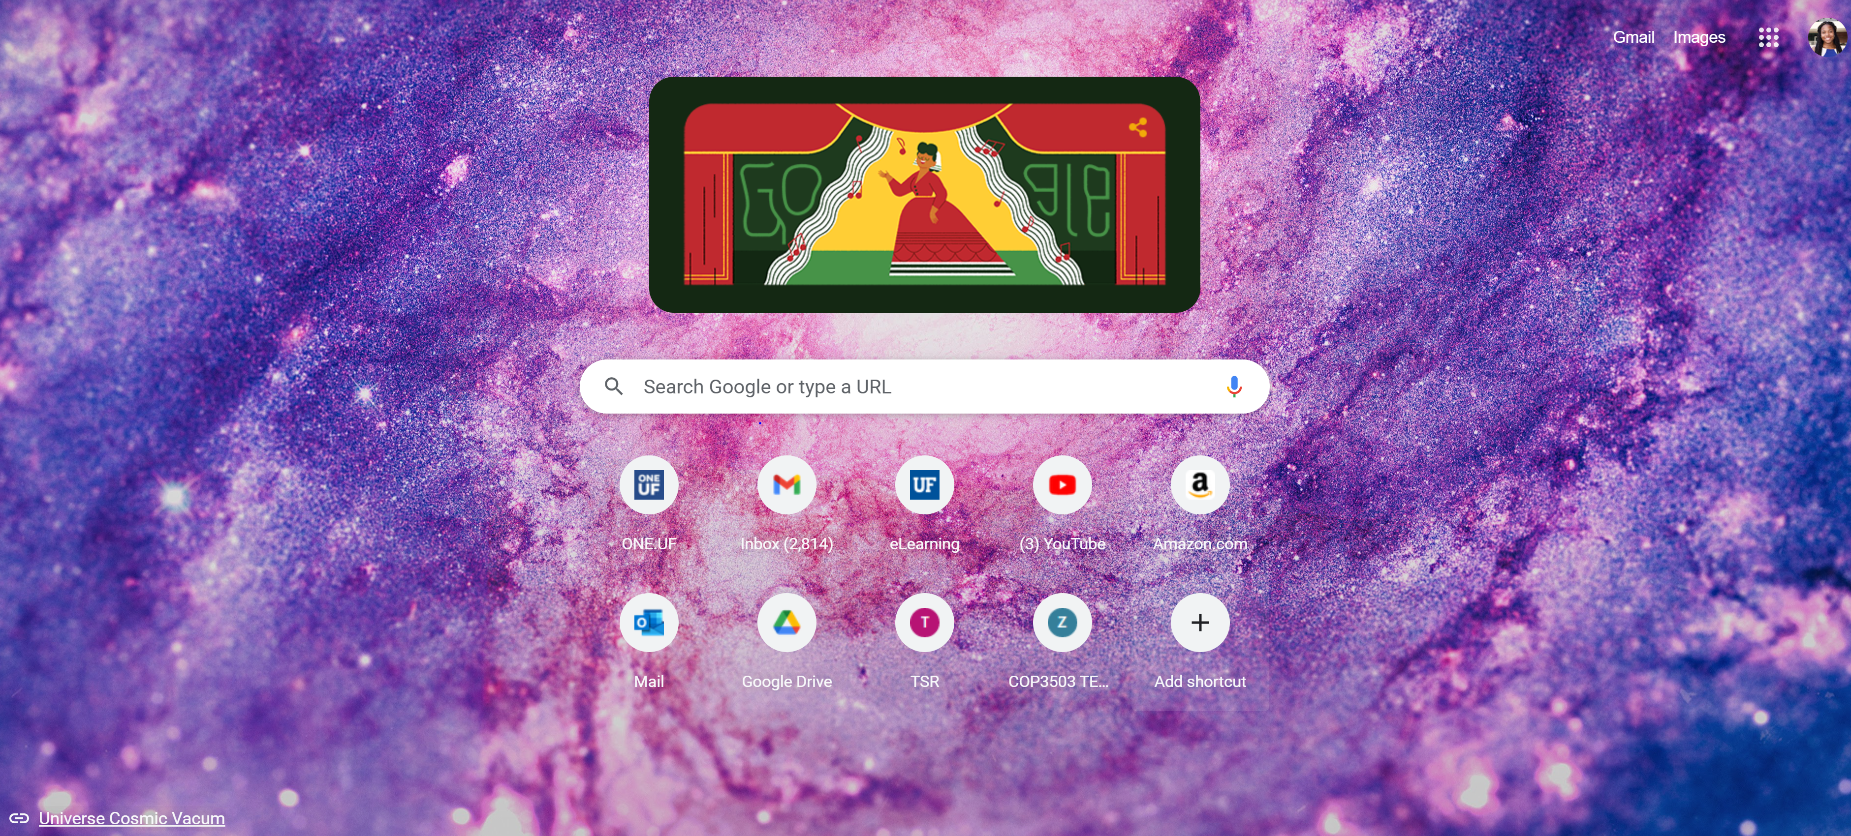
2. Go thru all the google applications
   1. 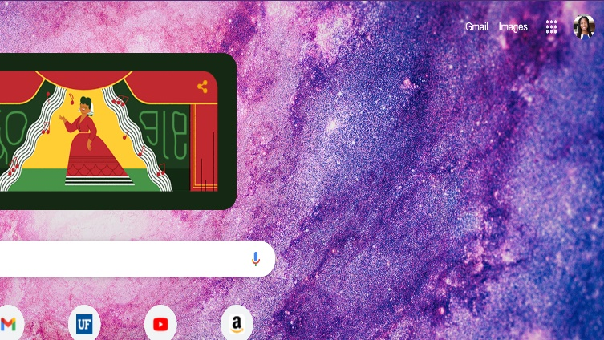If you click on this 2-D array of dots, another menu of a list of applications that are linked to your Google account will pop up! **DBA**
   2. 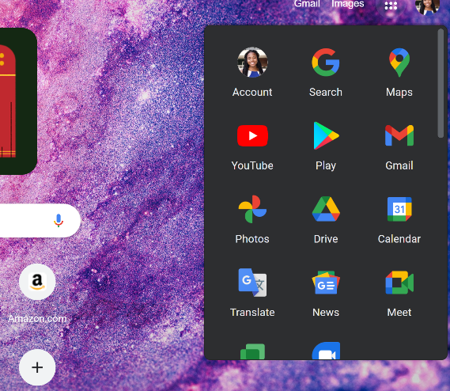You can click on each of these icons, which are links, to explore what Google has to offer. Google provides an applications such Youtube, Google calendar, maps, and a translator! **DBWA**
3. Click this small circle to see an enlarged image of your current profile picture. This image is made public to other gmail users. **DBA**
4. From here you can change your profile picture by clicking the camera icon located towards the bottom right of your current profile picture. **DBA**
   1. From this menu you can also add another account **DBA**
   2. 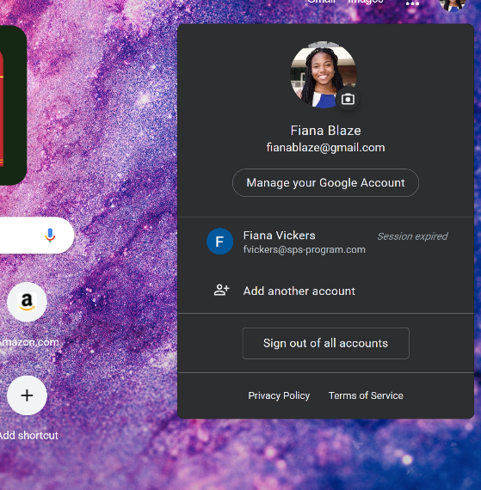Or manage you current account **DBA**
5. Now search bar and prompt to write it
   1. Now that you know of all the plentiful features Google offers its users on, all that’s left is to learn how to “Google it!” **DBWA**
   2. Click in this large search bar and just type anything that you would like to know more about. Then, press the enter key located on your keyboard, or click the magnifying glass to the left of the search bar to search for thousands of websites that are related to your topic. **DBA**
   3. 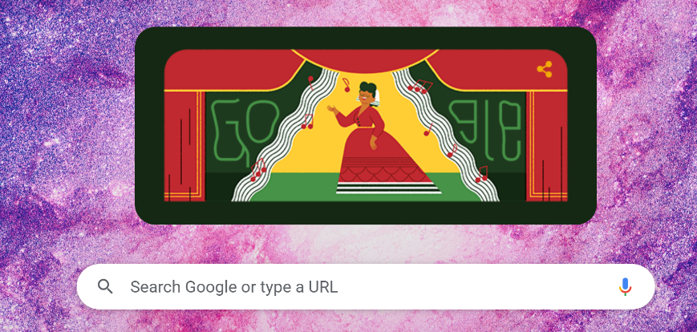that’s it! You have successfully completed a walkthrough and learned about all the resources Google provides as well as how to “Google it!” Enjoy Googling! 😊 **DBWA**